JAVA Assignment 1
- What is Java?
- Java is a cross platform Object oriented programming language.
- Is Java platform dependent or independent?
- Java is platform Independent.
- What is JVM?
- JVM stands for Java Virtual Machine.
- What is JDK and JRE?
- JDK stands for Java Development Kit and JRE stands for Java Run-time Environment.
- Why is Java called “Write Once, Run Anywhere”?
- Java uses JVM as a universal execution environment , which makes it possible to run a java program on any platform.
- What is a class in Java?
- A blueprint from which instance of class is created.
- What is an object?
- Instance of class which contains states and behavior.
- What is the main method in Java?
- It’s the method the JVM looks for to start running your program.
- What is the use of System.out.println()?
- System.out.println() is used in Java to print messages to the console.
- What are data types in Java?
- There are mainly two data types in Java:
Primitive and Non-primitive datatypes.
Primitive consists of byte,short ,int, long, float, double, char, Boolean.
Non- primitive consists String, Class, Array, Interface, Object.
- Give examples of primitive data types.
- Byte b = 10;
- Short s = 1000;
- Int x = 24;
- Long l = 142534266L;
- Float f = 3.14f;
- Double d = 99.99;
- Char c = ‘A’;
- Boolean flag = true;
- What is a variable?
- A variable in Java is a named storage location used to hold data.
- How do you declare a variable in Java?
- In Java, you declare a variable by specifying its data type followed by the variable name.
- Int age; , String name;
- What is the difference between int and float?
- Int stores whole numbers or integers but no decimals. For example, int age = 23;
- While float stores only decimal numbers. For example, float f = 99.99f;
- What is type casting?
- Converting a variable from one data type to another.
- Two types of casting is there – implicit and explicit type casting.
- What is the default value of int?
- Default value of int in java is zero(0).
- What is a keyword in Java?
- A keyword in Java is a reserved word that has a special meaning in the language and cannot be used as an identifier.
- Can we use reserved keywords as variable names?
- No.
- What is the difference between = and ==?
- = is an assignment operator : used for assigning a value to a variable.
- == is a binary (comparison) operator : used to compare two values for equality.
- What is an if statement?
- It is used to make decisions in a program.
- Difference between if and switch?
- If – statement is used for decision making with conditions.
- Switch statement is used for multiple choices .
- What is a loop?
- It is used to repeat a block of code multiple times until a condition is met.
- Types of loops in Java?
- There are three types of loops: for loop , while loop, do-while loop
- Difference between for loop and while loop?
- For loop is used when you know exactly how many times you want to repeat.
- While loop is used when repetition depends on a condition that may change unpredictably.
- What is break statement?
- Break statement is used to exit a loop or switch statement immediately.
- What is continue statement?
- The continue statement is used inside loops to skip the current iteration and move to the next one.
- What will happen if we don’t write the main method?
- The program will compile successfully but when you try to run the program , the JVM won’t know where to start the execution.
- Can we run a Java program without class?
- You cannot run a program without a class because Java is a class-based, object-oriented language.
- What happens if we don’t compile a Java program?
- If we don’t compile a Java program, the program cannot be executed.
- Can a variable change its data type?
- Data types cannot be changed but the values can be converted using typecasting.
- What is the size of int in Java?
- Size of int in java is 4 bytes (32 bits).
- Why Java does not support pointers directly?
- By not supporting , java ensures platform independence and it also ensures security of the program.
Q1. Write a Java program to declare variables of all primitive data types and print their values.
class Datatypes{
public static void main(String args[])
{
byte bt = 10;
short st = 4000;
int x = -45;
long l = 653715718982l;
float f = -5378;
double db = -6753;
Boolean bl = false;
char ch = 'S';
System.out.println("byte = " + bt);
System.out.println("short = " + st);
System.out.println("int = " + x);
System.out.println("long = " + l);
System.out.println("float = " + f);
System.out.println("double = " + db);
System.out.println("boolean = " + bl);
System.out.println("char = " + ch);

}
}
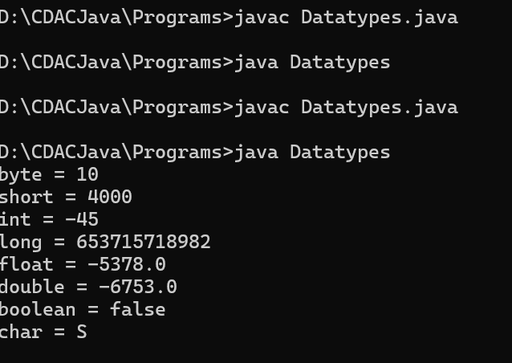

Q2. Take two numbers (int and double) and perform:
○ Addition
○ Division
○ Type casting result to int
import java.util.*;
class Arithmetic{

public static void main(String args[])
{
Scanner sc = new Scanner(System.in);
int a = sc.nextInt();
double b = sc.nextDouble();
int sum = a + (int)b;
int div = a / (int)b;
System.out.println(sum);
System.out.println(div);
}
}
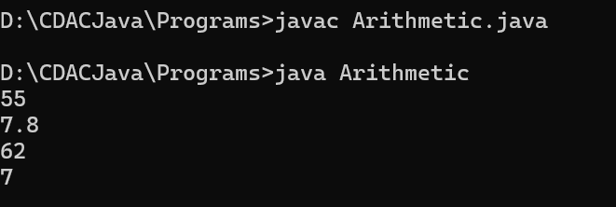

Q3. Write a program to convert:
○ int → double
○ double → int
import java.util.*;
class Conversion{
public static void main(String args[])
{
Scanner sc = new Scanner(System.in);
int x = sc.nextInt();
double p = sc.nextDouble();

// int to double
double y = (double) x;

// double to int
int r = (int) p;
System.out.println("After Conversion int to double :" + y);
System.out.println("After Conversion double to int :" + r);
}
}
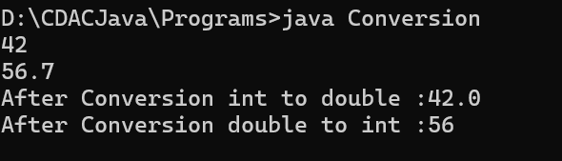

Q4. Write a program to find ASCII value of a character.
import java.util.*;
class Ascii
{
public static void main(String args[])
{
Scanner sc = new Scanner(System.in);
char ch = sc.next().charAt(0);
int x = (int) ch;
System.out.println("ASCII value of " + ch + " is " + x);
}
}
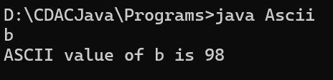

Q5. Take a character input and print:
○ Next character
○ Previous character
import java.util.*;
class Ascii
{
public static void main(String args[])
{
Scanner sc = new Scanner(System.in);
char ch = sc.next().charAt(0);
char x = --ch;
System.out.println("Previous character of is " + x);
char y = ++x;
System.out.println("Next character of is " + ++y);
}
}

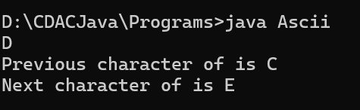

Q6. Write a program to check whether a number is:
○ Positive
○ Negative
○ Zero
import java.util.*;
class Checknumber
{
public static void main(String args[])
{
Scanner sc = new Scanner(System.in);

int x = sc.nextInt();
if (x > 0) {
System.out.println("Number is Positive");
} else if (x < 0) {
System.out.println("Number is Negative");
} else {
System.out.println("Number is Zero");
}
}
}
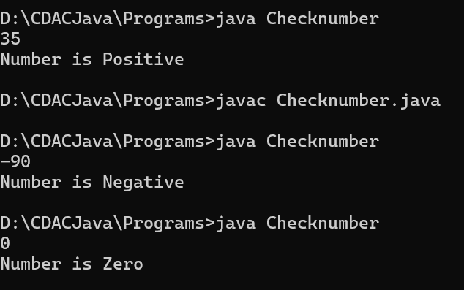

Q7. Write a program to find the largest of three numbers.
import java.util.Scanner;
class LargestNumber
{
public static void main(String args[])
{
Scanner sc = new Scanner(System.in);
int a = sc.nextInt();
int b = sc.nextInt();
int c = sc.nextInt();
if(a > b & a > c){
System.out.println("Largest number is " + a);
}else if(b > c){
System.out.println("Largest number is " + b);
}else{
System.out.println("Largest number is " + c);
}
}
}
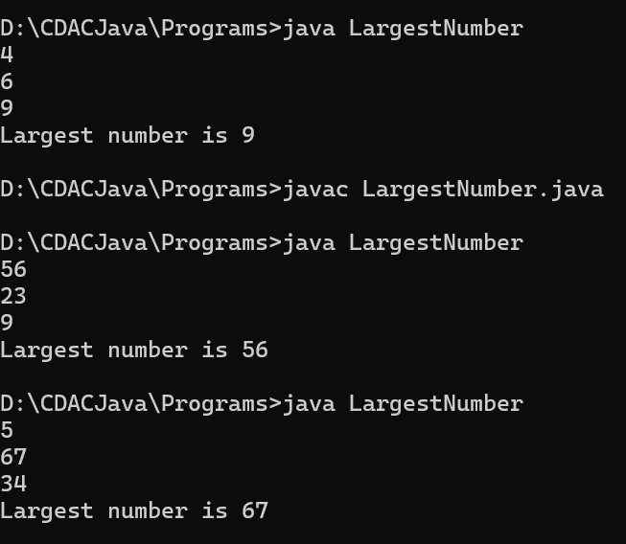
Q8. Write a program to check whether a year is a leap year.
import java.util.Scanner;

public class LeapYearCheck
{
public static void main(String args[])
{
Scanner sc = new Scanner(System.in);
int year = sc.nextInt();
if ((year % 4 == 0) && (year % 400 == 0 || year % 100 != 0)){
System.out.println("It is Leap Year.");
}else{
System.out.println("It is Not a Leap Year.");
}
}
}
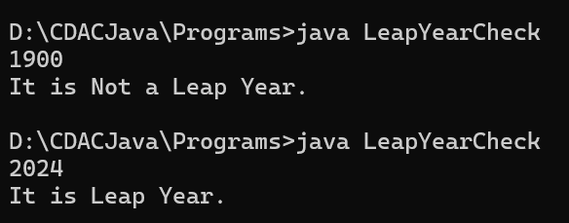

Q9. Create a simple calculator using switch:
○ Input: two numbers + operator
○ Perform: +, -, *, /
import java.util.Scanner;
public class Calculator
{
public static void main(String args[])
{
Scanner sc = new Scanner(System.in);
double a = sc.nextDouble();
double b = sc.nextDouble();
char operator = sc.next().charAt(0);
double result = 0;
switch (operator)
{
case '+':
result = a + b;
break;
case '-':
result = a - b;
break;
case '*':
result = a * b;
break;
case '/':
if (b != 0)
{
result = a / b;
}
else
{
System.out.println("Division by zero.");
}
break;
default :
System.out.println("Invalid Operator!");
}
System.out.println(" Result = " + result);
}
}
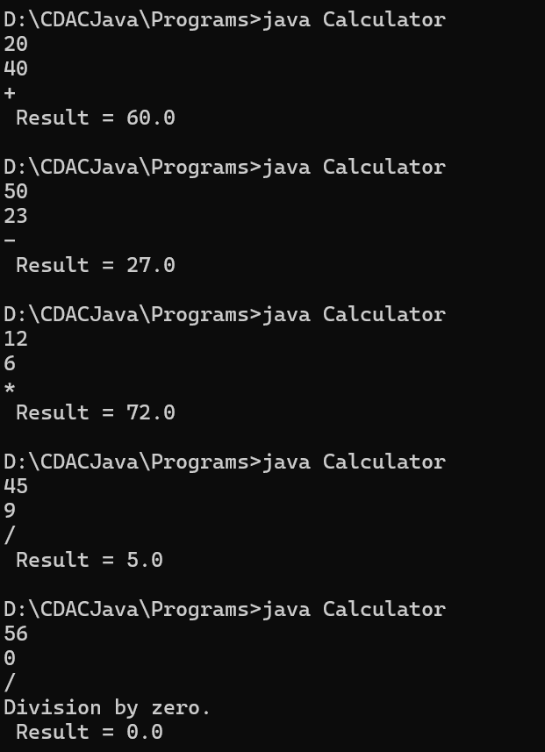

Q10. Write a program to check whether a character is:
● Vowel or consonant
import java.util.Scanner;
public class Lettercheck
{
public static void main(String args[])
{
Scanner sc = new Scanner(System.in);
char ch = sc.next().charAt(0);
if (ch == 'a' || ch == 'e' || ch == 'i' || ch == 'o' || ch == 'u')
{
System.out.println(ch + " is a Vowel.");
}else {
System.out.println(ch + " is a Consonant.");
}
}
}
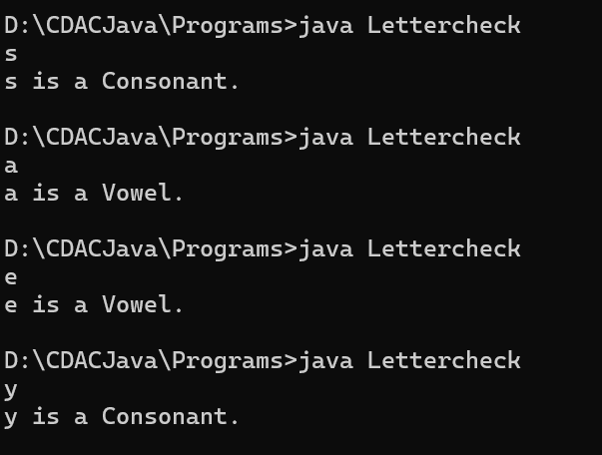

Q11. Print numbers from 1 to 50 using:
● for loop
import java.util.Scanner;
public class FiftyNumbers
{
public static void main(String args[])
{
Scanner sc = new Scanner (System.in);
int n = sc.nextInt();
for(int i = 1; i <= n; i++)
{
System.out.print(" " + i + " ");
}
}
}
● while loop
import java.util.Scanner;
public class FiftyNumbers
{
public static void main(String args[])
{
Scanner sc = new Scanner (System.in);
System.out.println(" Using While Loop");
int n = sc.nextInt();
int i = 1;
while(i <= n)
{
System.out.print(" " + i + " ");
i++;
}
}
}
Q12. Write a program to print sum of first N natural numbers.
import java.util.Scanner;
public class Sum
{
public static void main(String args[])
{
System.out.print("Enter N: ");
Scanner sc = new Scanner (System.in);
int N = sc.nextInt();
int sum = N * (N + 1) / 2;
System.out.println("Sum of 1st N natural numbers is : " + sum);
}
}
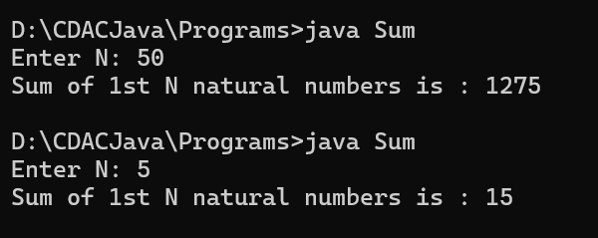

Q13. Write a program to print multiplication table of a number.
import java.util.Scanner;
public class Table
{
public static void main(String args[])
{
System.out.print("Enter N : ");
Scanner sc = new Scanner(System.in);
int n = sc.nextInt();
int mult = 1;
for(int i = 1; i <= 10; i++)
{
mult = i * n;
System.out.println(mult);
}
}
}
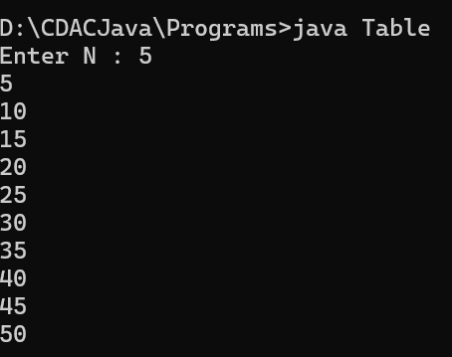

Q14. Write a program to reverse a number.
import java.util.Scanner;
public class Reverse
{
public static void main(String args[])
{
Scanner sc = new Scanner(System.in);
int num = sc.nextInt();
int rev = 0;
while(num != 0)
{
int digit = num % 10;
rev = rev * 10 + digit;
num = num / 10;
}
System.out.println("Reversed number is : " + rev);
}
}
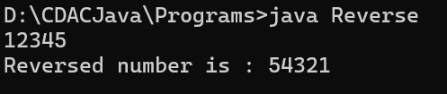

Q15. Write a program to count digits in a number.
import java.util.Scanner;
public class CountDigits
{
public static void main(String args[])
{
Scanner sc = new Scanner(System.in);
int num = sc.nextInt();
int count = 0;
while (num != 0)
{
int digit = num % 10;
count++;
num = num / 10;
}
System.out.println(count);
}
}
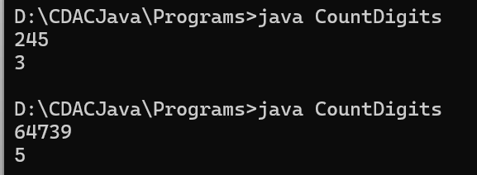

Q16. Write a program to check whether a number is palindrome.
import java.util.Scanner;
public class Palindrome
{
public static void main(String args[])
{
Scanner sc = new Scanner(System.in);
System.out.print("Enter the number: ");
int num = sc.nextInt();
int og = num;
int rev = 0;
while (num != 0)
{
int digit = num % 10;
rev = rev * 10 + digit;
num = num / 10;
}
if (og == rev)
{
System.out.println("The number is Palindrome.");
}else{
System.out.println("The number is Not a Palindrome.");
}
}
}
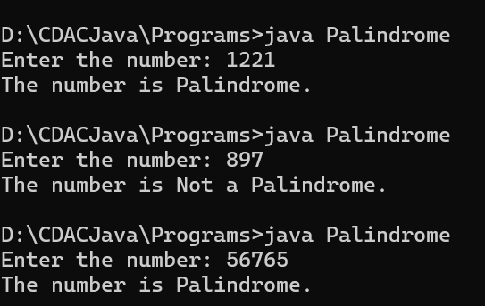

Q17. Write a program to find factorial of a number.
import java.util.Scanner;
public class Factorial
{
public static void main(String args[])
{
Scanner sc = new Scanner(System.in);
System.out.print("Enter the number: ");
int num = sc.nextInt();
int fact = 1;
for (int i = 1; i <= num; i++)
{
fact = fact * i;
}
System.out.println("Factorial of the number: " + fact);
}
}
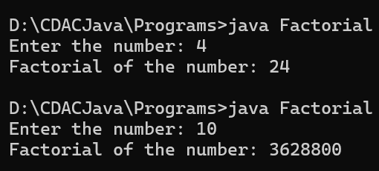

Q18. Write a program to print Fibonacci series up to N terms.
import java.util.Scanner;
public class Fibonacci
{
public static void main(String args[])
{
System.out.print("Enter N: ");
Scanner sc = new Scanner(System.in);
int n = sc.nextInt();
int first = 0;
int second = 1;
System.out.println(first);
System.out.println(second);
int fib = 0;
for (int i = 1; i <= n; i++)
{
fib = first + second;
System.out.println(fib);
first = second;
second = fib;
}
}
}
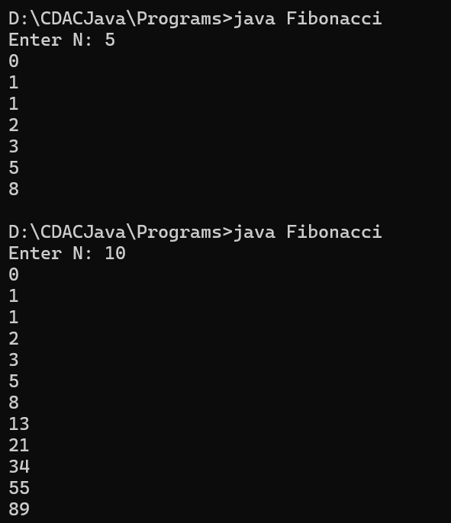

Q19. Print:
*
**
***
****
import java.util.Scanner;
public class PrintStar
{
public static void main(String args[])
{
Scanner sc = new Scanner(System.in);
int n = sc.nextInt();
for (int i = 1; i <= n; i++)
{
for (int j = 1; j <= i; j++)
{
System.out.print("*");
}
System.out.println();
}
}
}
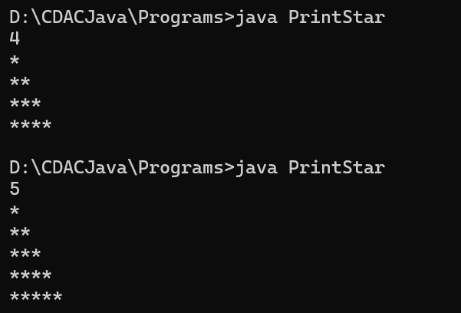
Q20. Print:
1
12
123
1234
import java.util.Scanner;
public class Pyramid
{
public static void main(String args[])
{
Scanner sc = new Scanner(System.in);
int n = sc.nextInt();
for (int i = 1; i <= n; i++)
{
for (int j = 1; j <= i; j++)
{
System.out.print(j);
}
System.out.println();
}
}
}
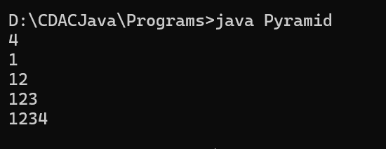
Q21. Print:
****
***
**
*
import java.util.Scanner;
public class PrintStar
{
public static void main(String args[])
{
Scanner sc = new Scanner(System.in);
int n = sc.nextInt();
for (int i = n; i >= 1; i--)
{
for (int j = 1; j <= i; j++)
{
System.out.print("*");
}
System.out.println();
}
}
}
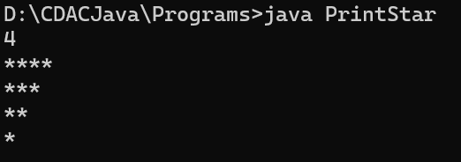
Q22. Write a program to check whether a number is prime.
import java.util.Scanner;
public class IsPrime
{
public static void main(String args[])
{
Scanner sc = new Scanner(System.in);
int num = sc.nextInt();
Boolean isPrime = true;
if(num < 2)
{
isPrime = false;
}
for (int i = 2; i <= Math.sqrt(num); i++)
{
if (num % i == 0)
{
isPrime = false;
break;
}
}
if(isPrime)
{
System.out.println("The number is Prime.");
}else{
System.out.println("The number is not a Prime.");
}
}
}
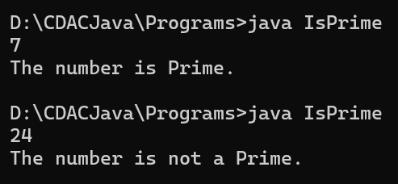

Q23. Write a program to find sum of even and odd numbers separately (1 to N).
import java.util.Scanner;
public class SumEvenOdd
{
public static void main(String[] args)
{
Scanner sc = new Scanner(System.in);
System.out.print("Enter the value of N: ");
int N = sc.nextInt();
int sumEven = 0;
int sumOdd = 0;
for (int i = 1; i <= N; i++)
{
if (i % 2 == 0)
{
sumEven += i;
} else {
sumOdd += i;
}
}
System.out.println("Sum of even numbers from 1 to " + N + " = " + sumEven);
System.out.println("Sum of odd numbers from 1 to " + N + " = " + sumOdd);
}
}
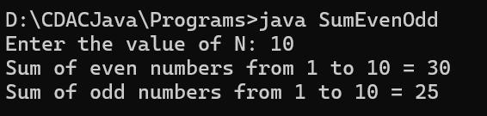

Q24. Write a program to find largest digit in a number.
import java.util.Scanner;
public class LargestDigit {
public static void main(String[] args) {
Scanner sc = new Scanner(System.in);
System.out.print("Enter a number: ");
int num = sc.nextInt();

int largest = 0;
while (num > 0) {
int digit = num % 10; // extract last digit
if (digit > largest) {
largest = digit; // update largest if needed
}
num = num / 10; // remove last digit
}
System.out.println("Largest digit = " + largest);
}
}
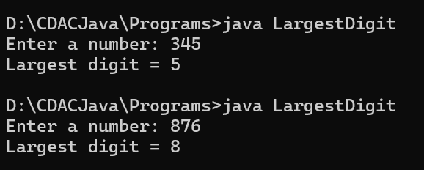

Q25. Write a program to swap two numbers:
● With third variable
● Without third variable
import java.util.Scanner;
public class Swapp {
public static void main(String[] args) {
Scanner sc = new Scanner(System.in);

// Input from user
System.out.print("Enter the value of a: ");
int a = sc.nextInt();
System.out.print("Enter the value of b: ");
int b = sc.nextInt();

// Swap using third variable
int t = a;
a = b;
b = t;
System.out.println("a : " + a);
System.out.println("b : " + b);
}
}
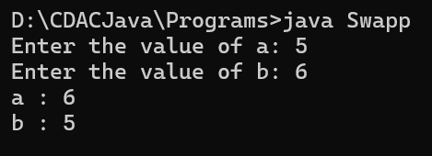

import java.util.Scanner;
public class Swapp2 {
public static void main(String[] args) {
Scanner sc = new Scanner(System.in);

// Input from user
System.out.print("Enter the value of a: ");
int a = sc.nextInt();
System.out.print("Enter the value of b: ");
int b = sc.nextInt();

// Swap without using third variable
a = a + b;
b = a - b;
a = a - b;
System.out.println("a : " + a);
System.out.println("b : " + b);
}
}
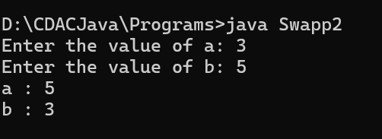

Q26. Write a program to check whether a number is Armstrong.
import java.util.Scanner;
public class Armstrong
{
public static void main(String[] args) {
Scanner sc = new Scanner(System.in);

// Input from user
System.out.print("Enter the value of num: ");
int num = sc.nextInt();
int original = num;
int sum = 0;
int n = String.valueOf(num).length();
while (num > 0)
{
int digit = num % 10;
sum += Math.pow(digit, n);
num = num / 10;
}
if (sum == original)
{
System.out.println(original + " is an Armstrong Number.");
}else{
System.out.println(original + " is Not an Armstrong Number.");
}
}
}
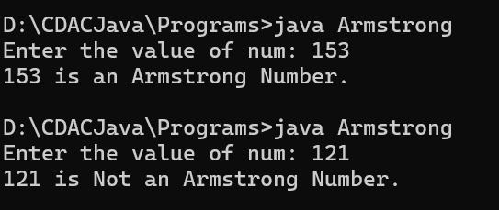
Q27. Take marks of 5 subjects and:
● Calculate total
● Calculate percentage
● Print grade (A/B/C/Fail)
import java.util.Scanner;
public class GradeCard
{
public static void main(String[] args)
{
Scanner sc = new Scanner(System.in);
int[] marks = new int[5];
int total = 0;
System.out.println("Enter marks of 5 subjects:");
for (int i = 0; i < 5; i++)
{
marks[i] = sc.nextInt();
total = total + marks[i];
}
System.out.println("Total Marks: " + total);
double per = (double) total / 500 * 100;
System.out.println("Percentage: " + per + "%");
char grade;
if (per >= 75)
{
System.out.println("Grade : A");
}else if(per >= 60)
{
System.out.println("Grade : B");
}else if(per >= 45)
{
System.out.println("Grade : C");
}else
{
System.out.println(" FAIL ");
}
}
}
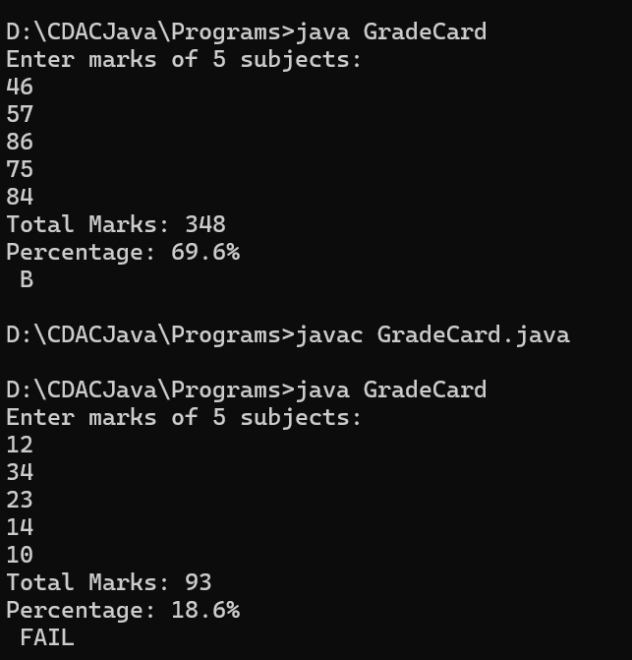
Q28. Take user age and:
● Check eligibility for voting
import java.util.Scanner;
public class VotingEligibility
{
public static void main(String args[])
{
Scanner sc = new Scanner(System.in);
System.out.print("Enter Age :");
int age = sc.nextInt();
if (age >= 18)
{
System.out.println("Eligible for Voting.");
}else{
System.out.println("Not Eligible for Voting.");
}
}
}
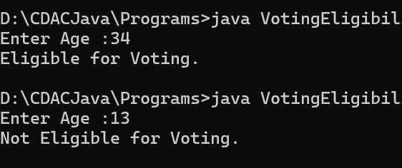

Q29. Create a menu-driven program:
1. Add
2. Subtract
3. Exit
import java.util.Scanner;
public class Menu_driven
{
public static void main(String args[])
{
Scanner sc = new Scanner(System.in);
int choice = 0;
while(choice != 3)
{
System.out.println("\n--- Menu ---");
System.out.println("1. Add");
System.out.println("2. Subtract");
System.out.println("3. Exit");
System.out.print("Enter your choice: ");
choice = sc.nextInt();
switch (choice)
{
case 1 :
System.out.println("Enter two numbers : ");
int a1 = sc.nextInt();
int b1 = sc.nextInt();
int result1 = a1 + b1;
System.out.println("Result = " + result1);
break;
case 2 :
System.out.println("Enter two numbers : ");
int a2 = sc.nextInt();
int b2 = sc.nextInt();
int result2 = a2 - b2;
System.out.println("Result = " + result2);
break;
case 3 :
System.out.println("Exiting the Program....");
break;
default :
System.out.println("Invalid Choice.");
}
}
}
}
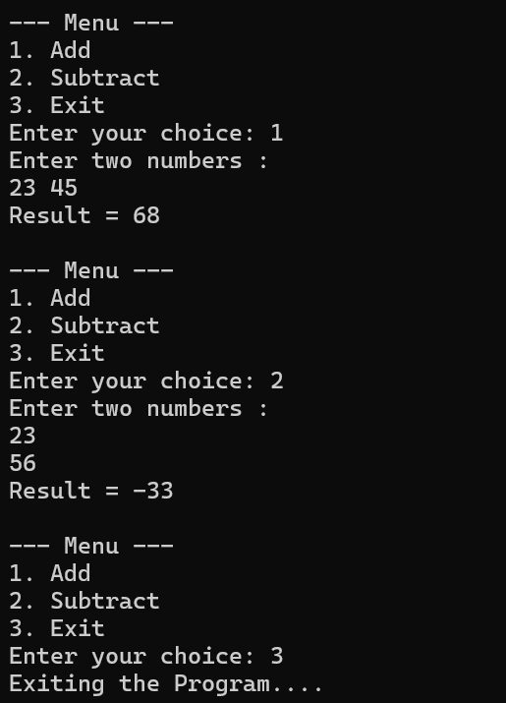
Q30. Take a number and print its table until user stops (use loop).
import java.util.Scanner;
public class TablePrinter
{
public static void main(String[] args)
{
Scanner sc = new Scanner(System.in);
char choice;

do
{
System.out.print("Enter a number to print it's table: ");
int num = sc.nextInt();
for (int i = 1; i <= 10; i++)
{
System.out.println(num * i);
}
System.out.print("Do you want to continue? (y/n): ");
choice = sc.next().charAt(0);
} while (choice == 'y' || choice == 'Y');
System.out.println("Program ended.");
}
}
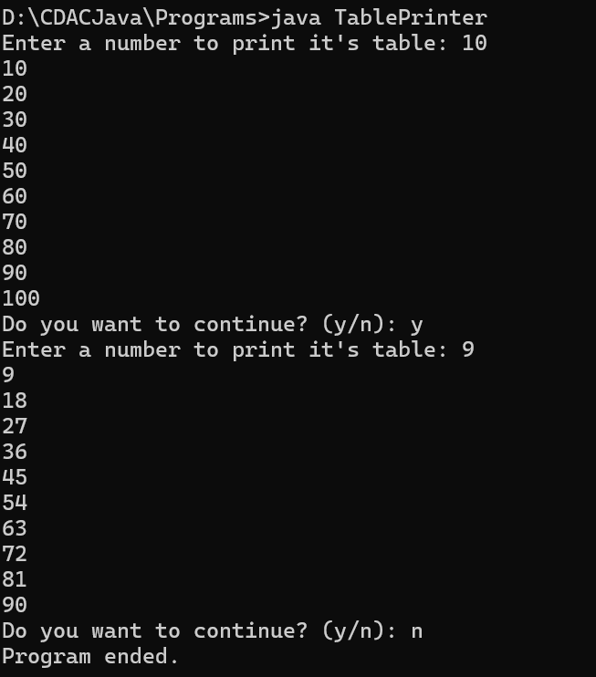
Q31. Fix the error:
int x;
System.out.println(x);
- int x = 10;
System.out.println(x);
Q32. Fix:
if(x = 10)
{
System.out.println("Hello");
}
- int x = 10;
if (x == 10)
{
System.out.println("Hello");
}
Q 33. Fix infinite loop:
while(i < 10)
{
System.out.println(i);
}
- int i = 0;
while (i < 10) {
System.out.println(i);
}

Q 34. Print all prime numbers between 1 to 100.
public class PrimeNumbers {
public static void main(String[] args)
{
System.out.println("Prime numbers between 1 and 100 are:");
for (int num = 2; num <= 100; num++)
{
boolean isPrime = true;
// check divisibility
for (int i = 2; i <= Math.sqrt(num); i++)
{
if (num % i == 0)
{
isPrime = false;
break;
}
}
if (isPrime)
{ System.out.print(num + " "); }
}
}
}

Q 35. Find GCD of two numbers.
import java.util.Scanner;
public class GCD {
public static void main(String[] args) {
Scanner sc = new Scanner(System.in);
System.out.print("Enter first number: ");
int a = sc.nextInt();
System.out.print("Enter second number: ");
int b = sc.nextInt();
int gcd = findGCD(a, b);
System.out.println("GCD of " + a + " and " + b + " = " + gcd);
}
public static int findGCD(int a, int b) {
while (b != 0) {
int temp = b;
b = a % b;
a = temp;
}
return a;
}
}
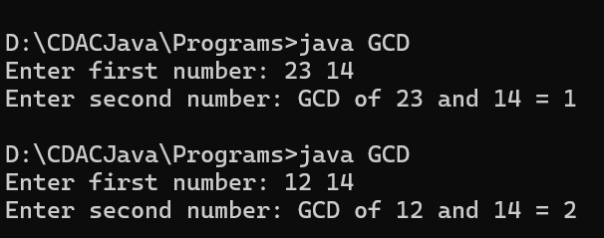
Q 36. Find LCM of two numbers.
import java.util.Scanner;
public class LCM {
public static void main(String[] args) {
Scanner sc = new Scanner(System.in);
System.out.print("Enter first number: ");
int a = sc.nextInt();
System.out.print("Enter second number: ");
int b = sc.nextInt();
int gcd = findGCD(a, b);
int lcm = (a * b) / gcd;
System.out.println("LCM of " + a + " and " + b + " = " + lcm);
}
public static int findGCD(int a, int b) {
while (b != 0) {
int temp = b;
b = a % b;
a = temp;
}
return a;
}
}
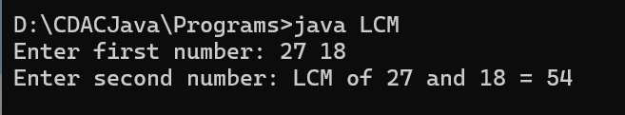

Q 37. Check whether a number is perfect number.
import java.util.Scanner;
public class PerfectNumber {
public static void main(String[] args) {
Scanner sc = new Scanner(System.in);
System.out.print("Enter a number: ");
int num = sc.nextInt();
int sum = 0;
for (int i = 1; i <= num / 2; i++) {
if (num % i == 0) {
sum += i;
}
}
if (sum == num) {
System.out.println(num + " is a Perfect Number.");
} else {
System.out.println(num + " is NOT a Perfect Number.");
}
}
}
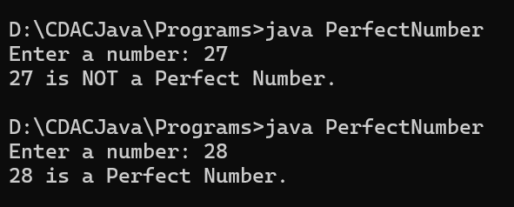
Q 38. Create a number guessing game.
import java.util.Scanner;
import java.util.Random;
public class GuessingGame {
public static void main(String[] args) {
Scanner sc = new Scanner(System.in);
Random rand = new Random();
int numberToGuess = rand.nextInt(100) + 1;
int guess;
int attempts = 0;
System.out.println("Guess the number between 1 and 100!");
do {
System.out.print("Enter your guess: ");
guess = sc.nextInt();
attempts++;
if (guess > numberToGuess) {
System.out.println("Too high! Try again.");
} else if (guess < numberToGuess) {
System.out.println("Too low! Try again.");
} else {
System.out.println("Correct! The number was " + numberToGuess);
System.out.println("You guessed it in " + attempts + " attempts.");
}
} while (guess != numberToGuess);
}
}
